Class05_R.R

Zhuohang_Wu

Thu Jan 24 09:32:32 2019

# Class 05 R grapgic intro  
  
# my first boxplot  
x <- rnorm(1000,0)  
boxplot(x)

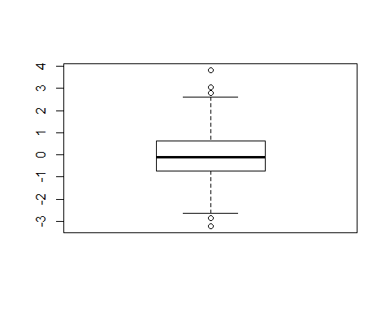

summary(x)

## Min. 1st Qu. Median Mean 3rd Qu. Max.   
## -3.21338 -0.73939 -0.08479 -0.05734 0.63727 3.82046

hist(x)

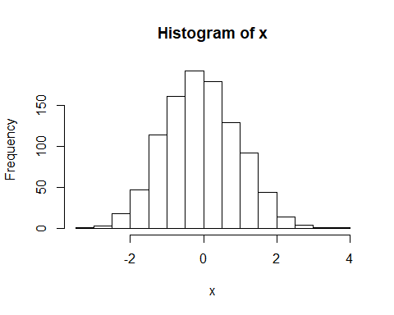

weight <- read.table("bimm143_05_rstats/weight_chart.txt", header=TRUE)  
plot(weight, pch=15, cex=1.5, lwd=2, ylim=c(2,10), xlab="AGE(Months)",   
 ylab="WEIGHT(Kg)", main="Baby Weight with Age")

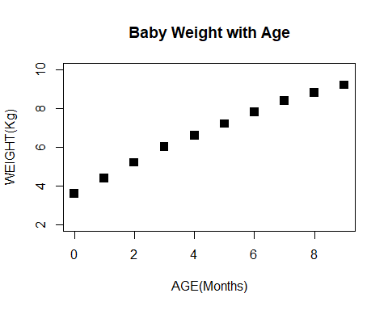

feature <- read.table("bimm143_05_rstats/feature_counts.txt", header = TRUE, sep = "\t")  
  
par(mar=c(5,12,4,3))  
barplot(feature$Count, horiz=TRUE, xlab="feature count", names.arg = feature$Feature,   
 main= "Feature Count", las=1, xlim = c(0,80000))

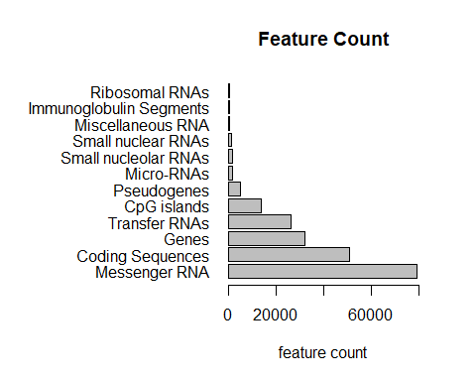

phenotype <- read.table("bimm143_05_rstats/up_down_expression.txt", header= TRUE)  
table(phenotype$State)

##   
## down unchanging up   
## 72 4997 127

palette(c("green", "red", "blue"))  
plot(phenotype$Condition1, phenotype$Condition2, col=phenotype$State,   
 xlab="expresscondition 1", ylab="express condition 2")

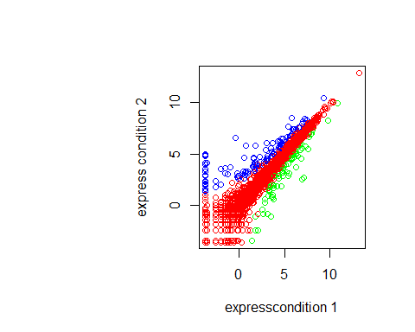

# Lets plot expresion vs gene regulation  
meth <- read.delim("bimm143_05_rstats/expression_methylation.txt")  
plot(meth$gene.meth, meth$expression)

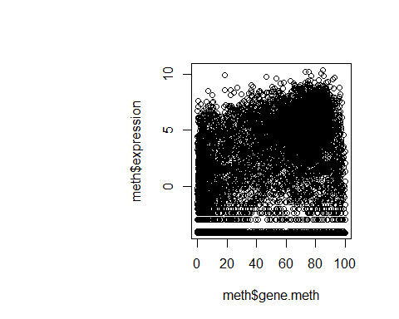

dcols <- densCols(meth$gene.meth, meth$expression)  
  
# Plot changing the plot character ('pch') to a solid circle  
plot(meth$gene.meth, meth$expression, col = dcols, pch = 20)

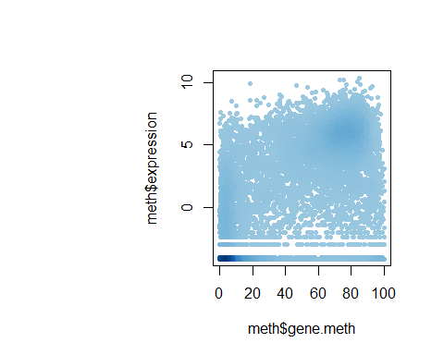

# Find the indices of genes with above 0 expresion  
inds <- meth$expression > 0  
  
# Plot just these genes  
plot(meth$gene.meth[inds], meth$expression[inds])

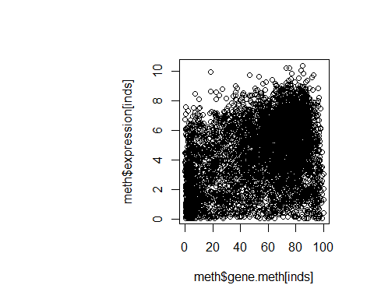

## Make a desnisty color vector for these genes and plot  
dcols <- densCols(meth$gene.meth[inds], meth$expression[inds])  
  
plot(meth$gene.meth[inds], meth$expression[inds], col = dcols, pch = 20)

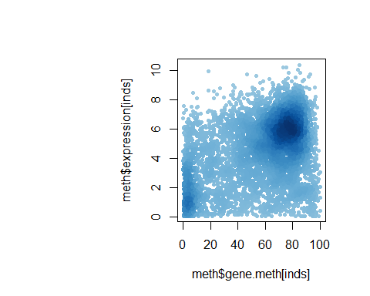

dcols.custom <- densCols(meth$gene.meth[inds], meth$expression[inds],  
 colramp = colorRampPalette(c("blue2",  
 "green",  
 "orange",  
 "red2")) )  
  
plot(meth$gene.meth[inds], meth$expression[inds],   
 col = dcols.custom, pch = 20)

